External Affairs Executive
Job purpose:

Provide project management and coordination in relation to the cross-team / cross-organisation development, communication and implementation of the large firm member offer and large in house member offer, engagement, communication and content strategies, annual segment and member workplans, including other cross-team / cross-organisation projects and initiatives led by External Affairs.

Key Accountabilities:
- Work closely with the External Affairs Managers to plan and execute cross-team / cross-organisation processes, projects and initiatives involving (but not limited to) membership engagement, public affairs, international, communications and content.
- Manage and execute projects in relation to our membership offer to the largest 150 member firms, largest 50 in house teams, city and business groups and associated groups/individuals with influence in this practitioner and policy area
- Manage the implementation of other plans and strategies as assigned
- Support the effective operations of cross-team groups such as the large firm member offer group e-newsletter production, and others as assigned
- Liaise with internal stakeholders, solicit input and information, predict resources needed to reach objectives and manage timelines, processes and resources in an effective and efficient manner to ensure that projects are delivered on time and according to accepted criteria
- Develop and manage a detailed project schedule and work plan provide project updates on a consistent basis to various stakeholders about strategy, plans and progress
- Seek input from stakeholders and manage communications in relation to the projects and workplans
- Utilise industry best practices, techniques, and standards of project management throughout entire project execution and continuously improve the project management process and identify areas for improvement
- Support the effective collection and reporting of member engagement data for the largest 150 firms and 50 in house group, using CRM, Power BI and other systems as appropriate
- Propose and implement ideas for the continuous improvement of cross-team / cross-organisation processes, projects and initiatives
- Provide other project management support:
  - Take meeting minutes / notes and actions and proactively manage follow up so actions are completed on time and to high standard
  - Schedule and support meetings: plan, organise, take part, provide topical updates, circulate agenda, prepare papers, actions and minutes
  - Be a key contact touchpoint for members, communicating clearly and quickly and maintaining high standards of customer service and quality
- Take ownership of assigned projects and be the first point of call to respond to project and stakeholders’ inquiries and issues
- Collate, interpret and analyse data and information and prepare and write reports
- Maintain excellent knowledge of the organisation’s business plans, processes, goals and capabilities and use it for efficient and effective project management
- Establish excellent day-to-day working relations and processes with international, Communications and Content, Events, Marketing, Learning and Development, Sponsorship and Partnership, Policy and within the External and Public Affairs Teams
- Other project management duties as assigned from time to time

Knowledge, skills and experience

Essential

- Critical thinking at degree level

- Experience of working on substantial projects with senior executives and Board Members, an ability to develop and maintain close working relationships with them and their teams

- Excellent project management, communication, presentation skills, report writing and drafting skills

- Ability to conduct substantial research, identify the key information/messages and be able to effectively communicate these

- High level of initiative, problem solving and decision-making skills

- Excellent organisation skills and attention to detail

- Excellent ability to build, develop and maintain working relationships with other team members and with senior internal and external stakeholders

- Excellent analytical, computer and database skills

- Ability to multitask and work independently under pressure

- Ability to project a positive and confident image of TLS

- A good working knowledge of other cultures and business practices

- Ability to exercise sound judgement across a range of complex and diverse issues

- Experience of overseeing the work of others to ensure work is delivered on time and to a high standard

- Strong influencing and negotiating skills

- A proactive, action orientated and delivery focused approach

Desirable

Planning & Organising  - Able to work autonomously to complete work on time and to a high standard  - Evaluate and apply judgement using own initiative, referring to the Director or other senior colleagues where necessary.  - Develop a thorough understanding of TLS organisational relationships and processes  - The role holder will be required to work effectively under pressure, and to deadlines | Organisation Chart  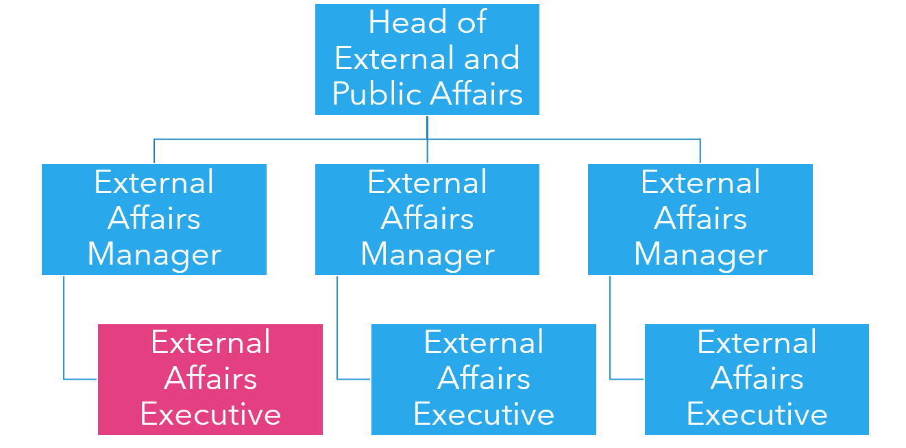
Dimensions

Operating environment

Financial responsibility
Creative Responsibility
Analytical Responsibility
Location

